Week 3
- Write a java program to add the two numbers.
Program:
package week3;
public class sumoftwonum{
public static void main(String[] args){
int a=28;
int b=17;
int sum=a+b;
System.out.print("Sum = "+sum);
}
}
Output:
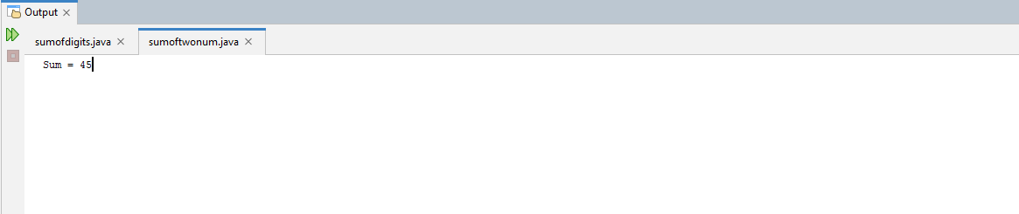

- Write a java program to multiply two floating numbers.
Program:
package week3;
public class floatproduct{
public static void main(String[] args){
double a=5.40;
double b=1.78;
double pro=a*b;
System.out.print("Product = "+pro);
}
}
Output:
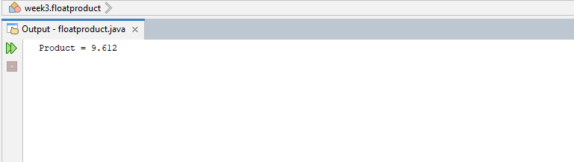
- Write a java program to display a cube of a number.
Program:
package week3;

public class cube{
public static void main(String[] args){
int num=7;
int cube=num*num*num;
System.out.print("Cube of "+num+" is "+cube);
}
}
Output:
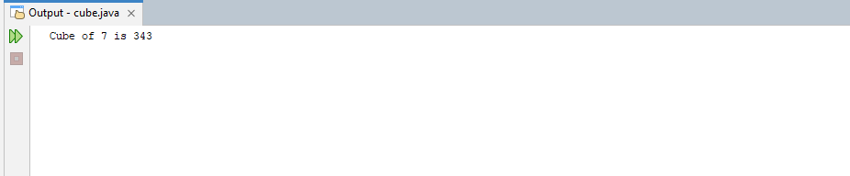
- Write a java program that takes three numbers as input to calculate and print the average of the numbers.
Program:
package week3;
import java.util.Scanner;

public class avgofthree{
public static void main(String[] args){
//creating a scanner object to read input:
Scanner scanner=new Scanner(System.in);
System.out.print("Enter Integer-1: ");
int a=scanner.nextInt();
System.out.print("Enter Integer-2: ");
int b=scanner.nextInt();
System.out.print("Enter Integer-3: ");
int c=scanner.nextInt();
double avg=(a+b+c)/3.0;
System.out.println("Average of "+a+", "+b+" and "+c+" is: "+avg);
}
}
Output:
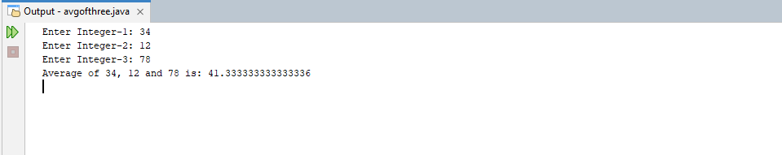
- Write a java program to compute the distance between two points.
Program:
package week3;

public class distance{
public static void main(String[] args){
double x1=4, y1=2;
double x2=1, y2=6;
double distance;
distance=Math.sqrt(Math.pow(x2-x1,2)+Math.pow(y2-y1,2));
System.out.print("Distance Point 1 and Point 2 is: "+distance);
}
}

Output:
